**What is POP3?**

POP3 (Post Office Protocol Version 3) is an email retrieval protocol used to access and manage emails stored on a mail server. It allows users to download and delete messages, providing offline access to emails. POP3 clients like Microsoft Outlook and Apple Mail use this protocol to retrieve messages from the server.

**Working of POP3**

1. **Connection Establishment**: POP3 initiates a secure connection between the client and server.
2. **Command Exchange**: Commands are exchanged to request and manage email tasks.
3. **Message Retrieval**: The server sends available messages with their sizes and identifiers.
4. **Message Download**: The client requests and downloads selected messages.
5. **Message Management**: The client can mark messages as read, unread, or delete them.
6. **Connection Termination**: Once tasks are completed, the client requests to close the connection.
7. **Acknowledgment**: The server acknowledges the request and closes the connection.

**POP3 Ports**

POP3 makes use of two network ports. They are:

* **Port 110:**Port 110 is a default TCP port used by POP3. But It has a disadvantage that it does not support encrypted communication.
* **Port 995:**Port 995 is majorly used for more secure applications. Port 995 is a [TLS](https://www.geeksforgeeks.org/transport-layer-security-tls/) or [SSL](https://www.geeksforgeeks.org/secure-socket-layer-ssl/) port used to provide more security.

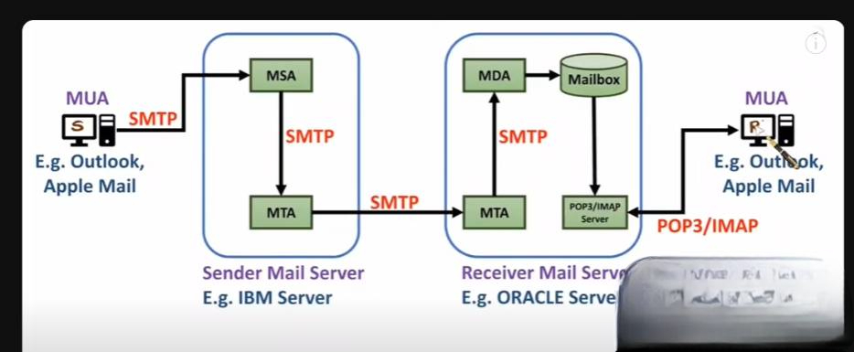

**Advantages of POP3**

* Allows offline email reading.
* Requires less server storage space.
* Easy to configure and widely supported by email applications.
* Quick access to locally stored emails.
* Unlimited email size for sending and receiving.

**Disadvantages of POP3**

* No real-time synchronization.
* Vulnerable to virus attachments affecting the system.
* Does not support simultaneous access to the same email on different systems.
* Entire email folders can be accidentally discarded.
* Local email folders may be accessible to other users of the computer.

